Technical Document – Annexure I
of
Shipping App
for
TOM MELVIN

Contents

Annexure I 3
1. Project Overview 3
2. Technologies 4
3. Features and Scope of Work 5
3.1. Mobile App Flow for Users 5
3.2. Administrator Web Panel 11
4. Draft Delivery Timeline and Gantt chart 13
5. Project Management 14
6. Proposed Team of Project 15

Annexure I

Project Overview
- Business Need
The business need for YHOTY APP is to empower users in Africa, particularly in regions with limited e-commerce access, by providing a secure mobile payment solution. The application facilitates generating prepaid virtual cards with international addresses, ensuring users can make purchases from global platforms and receive shipped items to their local addresses through a streamlined process.
- Target Audience
Customers/Users
- Stakeholders
Actor | Task
Users | Who would be using this app to purchases from global platforms and receive shipped items to their local addresses through a streamlined process.
Admin | Who will be controlling the whole app and it’s functionalities from backend.
- Project Scope and Development Deliverables
This project scope comprises of the following components to deliver:
- Design and Development of Shipping Mobile Application (IOS & Android)
- Development and Integration of API
- Development of Admin Web Panel

Technologies
Development Phases |  | Tools & Technology
Requirement  Gathering and Analysis | Proposal Drafting, SRS Writing and User | Microsoft Office Word 2019 / Microsoft Office Presentation 2019 /
Development | Mobile App | React Native / Flutter
Development | Web Backend | Node.js / PHP (Laravel)
Development | Database | MongoDB / MySql
Development | Browser | Google Chrome, Safari, Mozilla Firefox
Quality Assurance  & Testing | Test Cases | MS Office Excel 2019
Quality Assurance  & Testing | Testing | Manual

Features and Scope of Work

Mobile App Flow for Users
- Splash Screen
  - The launch screen of the Application where end users will be able to view the company’s logo.
- Welcome Screen
  - Screen describing the End User Application with the help of images.
- Authentication
  - This module consists of the registration and login functionalities.
  - Sign Up / Register
    - Users will be able to register using below details and after clicking on register user needs to give answers for few basic things
      - Full name
      - Mobile Number / E-mail ID
      - Password
      - Confirm Password
  - OTP Verification
    - The users will receive an OTP over their mobile number OR E-mail ID for verification after which the user would be successfully registered on the application.
  - Login
    - The users will be able to login into the application using the below details:
- Mobile Number / E-mail ID
- Password
- Checkbox to “Keep me Logged In”.

  - Forgot Password
    - A hyperlink present on the authentication screen clicking on which user would be redirected to the Forgot Password screen where user need to enter the below details:-
      - Mobile Number (To receive the OTP for verification).
      - OTP
    - After the OTP is verified user would be asked to mention below details in order to
change the password:-
      - New Password
      - Confirm New Password
- Advance Listing Features:
  - Home Screen:
    - User will be able to see a banner on the home screen.
    - User will be able to see an option on the home screen for setting up a virtual card. User will be redirected to “Create Virtual Card”.
    - Hamburger Menu
      - Home
      - About Us
      - Privacy Policy
      - Track My Order
      - Redeem Code
      - Terms and Conditions
    - My Profile
      - Edit Profile
      - Change Password
      - Logout
      - Delete Account
    - Bottom Bar
      - Home
      - My Virtual Visa Card
      - Add Shipping
      - My Profile
    - Notification
  - My Profile:
    - Profile: Users will be able to view/edit their profiles.
    - Change password: Users will be able to change their passwords.
  - Creating a Virtual Card:
    - User will be able to see a dedicated card section.
    - User will click on create my card
    - User needs to select the currency out of the 3 available ones (USD, EUR, GBP)
    - If users select the USD and enters the amount that amount will be shown in a separate field based upon local currency of the location.
    - User will be able to get a DVC (Delivery Verification code) which will be unique after creating the virtual card once topped up is completed.
    - This virtual card will also have country address on it.
Note: User can top up the card only once and after transactions that will be of no use and remaining amount will be credited to his app account and user can redeem the amount.
  - Topping Up the Card:
    - User navigates to the "Cards" section.
    - Chooses "Top Up a Card."
    - Enters the desired top-up amount.
    - User will be able to top up the card using debit card or credit card / Wallet (3rd Party).
    - Completes the payment process.
  - DVC (Delivery Verification Code):
    - User will be able to get a DVC once they create a visa virtual card.
    - User will be able to use this once they do the shipping transaction.

  - Shipping Criteria:
    - Once the shopping is done user will use the Yhoty app for further process.
    - User will be able to deliver their product from one country to another.
    - In order to complete the shipping process user needs to provide details listed below:
- Select shipping from Country
- Select shipping to Country
- Item Weights (Kg)
- Item weight ( cm)
- Item width ( cm)
- item height ( cm)
- Item description box
Note: shipping amount will be calculated based upon the above details.
    - Once these details are filled Yhoty will generate an invoice/quotation.
    - User needs to accept the invoice/quotation.
    - User will be able to see an option wherein they can enter their redeemed code.
    - Upon acceptance user will be able to see a payment screen which will initially ask for the DVC.
    - Once DVC is verified user will be asked to make the payment and complete the shipping transaction.
Note: 3rd party payment gateway will be integrated for making payments.
  - Notification:
    - User will be able to get the notification once their virtual card is added.
    - User will be able to get notification when their order is shipped.
    - User will be able to get a notification along with the tracking number.
    - User will be able to see once their card amount is about to get over.
    - User will be able to see a notification which says “Please top up your card”.
    - Upon clicking on this message user will be redirected to the card top up screen.
  - My Orders:
    - User will be able to see all the past orders they have done.
    - User will be able to see the list of all the orders which have been completed in the past.
  - Order Tracking:
    - User will be able to track their order using the order tracking number.
    - User needs to type in the order number in order to check the status.
    - User will be able to see dedicated section which allow the users to gain knowledge about the current status of order.
    - User will be a vertical line which will have points all over it.
    - These points will work as a checkmarks denoting the current location of the order.
Note: Admin will manually edit the tracking status
  - Redeem Code:
    - User will be able to redeem the amount which is the left over amount of the card they have created initially.
    - After using one card the app will remove that card and the rest amount can be redeemed from Redeem my code option.
    - Upon clicking here user will be able to see a code which comes after redeeming it and user can use these codes while doing the shipping.
  - About Us
    - The About Us page gives detail about us, why it was created, who it’s for, and what makes the app unique in the industry.
  - Privacy, Terms and Conditions
    - Terms and conditions, encompassing service agreements and contracts.
    - The terms include a privacy policy, securing data protection and defining conduct standards.
  - Log Out
    - Clicking on this a pop-up would be displayed as “Are you sure you want to Log Out from the Application?” with Cancel and Sure button.
      - If user clicks on Cancel button, then the User would remain on the same screen.
      - If user clicks on Sure button, then the user would be logged out from the Application and would be re-directed to the authentication screen.
  - Delete Account
    - Clicking on this a pop-up would be displayed as “Are you sure you want to Delete your Account?” with Cancel and Sure button.
      - If user clicks on Cancel button, then the user would remain on the same screen.
      - If user clicks on Sure button, then the user would be logged out from the Application and would be re-directed to the authentication screen.

Administrator Web Panel
The back end of the platform will be power packed with an administrative panel to manage the updates of data at the application level, website level and as well as back end.
Following would be the key functionalities:
- User Management
  - Admin will be able to manage the users.
  - Admin will be able to View/search the users.
  - Admin will be able to delete, activate or deactivate any particular user.
- Virtual Card Management
  - Monitor and manage virtual cards.
  - View details of created cards.
  - Track card usage and transactions.
  - Handle card top-up activities.
- Shipping Management
  - View and manage shipping transactions.
  - Access shipping details, including shipping addresses and items.
  - Track the status of shipping transactions.
  - Handle invoicing and quotation processes.
- Redeem Code Management
  - Monitor redeem code activities.
  - View details of redeemed codes.
  - Manage the process of generating and using redeem codes.
- Notification Management
  - Send push notifications to users.
  - Manage notification content and delivery.
  - Monitor notification logs.

- Order Management
  - View and manage user orders.
  - Access details of completed and ongoing orders.
  - Track order status and shipping progress.
- Content Management
  - Manage content displayed on the application, such as banners and promotional images.
  - About Us
  - Update information on the welcome screen.
- Finance Management
  - Track financial transactions, including card top-ups and shipping payments.
  - Generate financial reports.
  - Manage financial aspects related to the application.

Draft Delivery Timeline and Gantt chart
Planned Project Start Date | Scheduled Project Completion Date
Project Duration* | 100
22-Jan-2024 | 28-May-2024
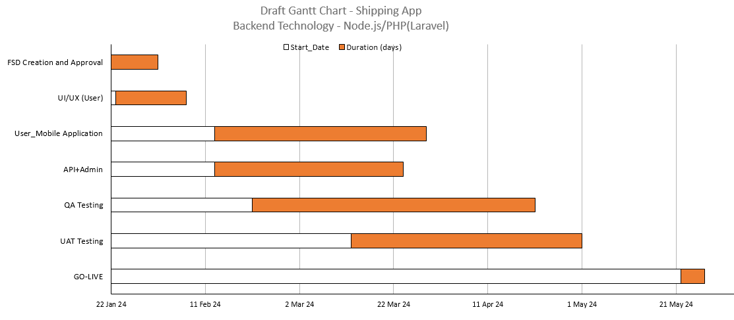
*Project Duration would be met with a condition that the client responses are received
on time.

Project Management
Before Project is awarded
Business Analysis | Project Management / Software Development | Business Development / Sales | Accounting
- Project Identify / Analysis  - Develop one-page proposal overview  - Create project management overview  - Tom assigned to business  manager GBM  GBM: Global Business Manager | - Project Evaluation by technical teams  - Introduction call 1 on 1 interaction with Tom  - System-appropriate services determined  - Requirements / System application architecting  - Project needs analysis  - Detailed proposal development  - Cost and Time effort estimation | - Introduction call  - Deliverables discussed with Tom  - Milestones discussed  - Project success discussed  - Future growth alignment  - Detailed proposal provided  - Payment instructions | - Invoice submitted to Tom  - Payment received  - Payment confirmation sent to Tom  - Account forwarded to PM

After Project is awarded
Phase 1 | Phase 2 | Phase 3 | Phase 4
- Project manager assigned  - Project initiation/ introduction call  - Online project profile created  - Weekly project meetings scheduled  - Reporting formats explained to <CLIENT NAME> | - Design, Development / technical teams assigned  - Project start  - Tom feedback on weekly  - Weekly project feedback session- 30 min  - Reports available on-line  - Online Rebel catering access of PM system application | - Testing / Quality Assurance  - Live server  testing  - Final bugs issues fixed  - Campaign completed | - Periodic project maintenance  - Data backups  - Web site –System application upgrades  - On line marketing ** Optional

Proposed Team of Project
The proposed team to achieve the deliverables in a time span of 20 Business Weeks
comprising of 40 hrs. /week is as follows
Designation | Availability
Project Manager | Part Time
Project Expert | Part Time
Designers | Full Time
Developers | Full Time
Quality Analyst | Full Time

